3976_ASN creation allow duplicate po and poline in 1 invoice
Date: 2013.03.28

Background: request from Epson to create WMS ASN based on shipping invoice documents.
Strictly line by line in the invoice detail.

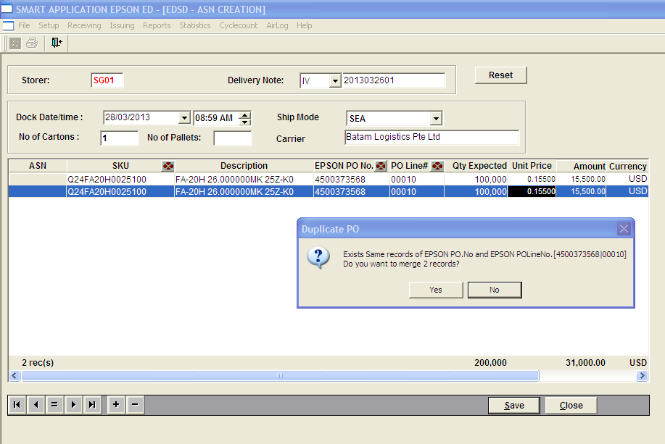

- System validate same PO/Poline creation. If same PO/POline found, message will prompt “…. Do you want to merge 2 recods? ”
Click [Yes] – to merge 2 asn line
Click [No] – to create separate lines

Same PO/POline created:

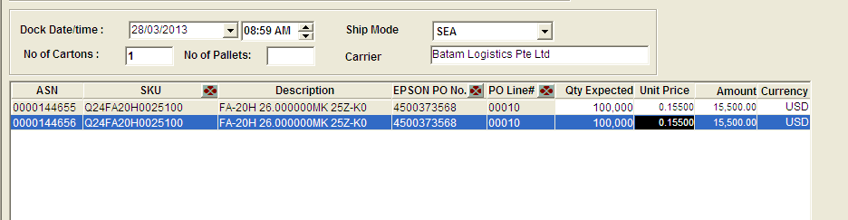

- Validate PO qty : system does not allow total qty expected from same po/poline more than PO order qty.
